Probability Calculations

Exercise : Calculate the following probabilities :

1. Probability that a normal random variable with mean 22 and variance 25

(i) lies between 16.2 and 27.5

Input:

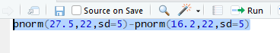

Output:



(ii) is greater than 29

Input

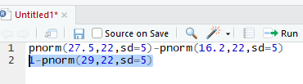

Output:



(iii) is less than 17

Input:

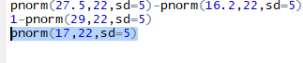

Output:



(iv) is less than 15 or greater than 25 2.

Input:



Output:



Probability that in 60 tosses of a fair coin the head comes up

1. 20,25 or 30 times

Input:



Output:



1. less than 20 times

input:



Output:



1. between 20 and 30 times

input:



Output:



3. A random variable X has Poisson distribution with mean 7.

Find the probability that

1. X is greater than 10

Input:



Output:



1. X is less than 5

Input:



Output:



1. X is between 4 and 16





Random Variable generation

Exercise (Advanced) : Generate 500 samples from Student’s t distribution with 5 degrees of freedom and plot the historgam. (Note: t distribution is going to be covered in class). The corresponding function is rt .

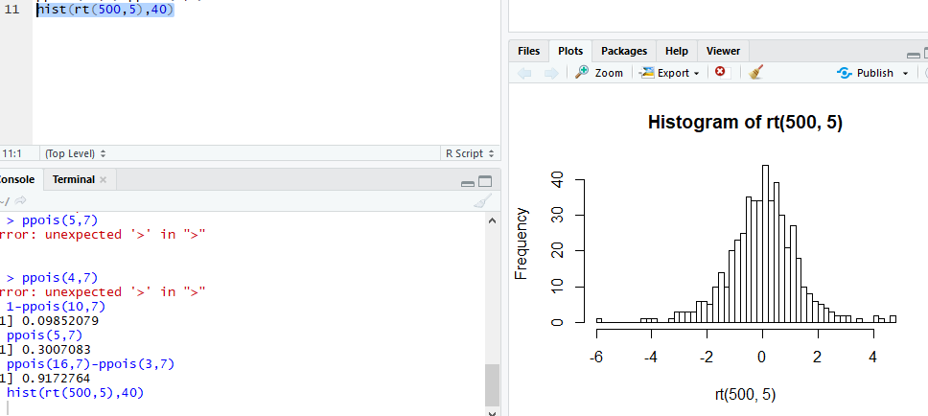

Density Plots

Exercise : Plot the probability mass functions for the Poisson distribution with mean 4.5 and 12 respectively. Do you see any similarity of these plots to any of the plots above? If so, can you guess why

?

Exercise : Recreate the probabilities that Professor Holmes did in class (Bin(5,.4)) [You can do it in 1 command!] How would you get the expected counts?

Q-Q plot

Exercise : Generate 100 samples from Student’s t distribution with 4 degrees of freedom and generate the qqplot for this sample. Generate another sample of same size, but now from a t distribution with 30 degrees of freedom and generate the q-q plot. Do you see any difference ?

